Leader Preparation
- Take some time to look over these questions ahead of time. Choose the ones that you want to make sure you cover with your group. We have highlighted what we think are key questions by bolding them.
- Pray for your group and your time together as you prepare. This is so helpful!
- When meeting online you as the leader will need to be more directive then in person. Don’t be afraid to invite everyone to answer a question, invite them to share by name, and thank them when they finish. The online format requires a little more intentional orchestrating then an in person group.
- Try to start the gathering be getting everyone talking at least once to begin. The Hook section is great for this. When in doubt, have people share stories about their past. (How the week was, favorite memories about the topic for the day, etc). This is a great way to help your group continue to get to know one another.
- Next look at the Scripture and what it means. We believe Jesus is discipling people through this Word. Get people into the Scriptures and the Scriptures into people!
- Finally, end with what God is saying to people and how God is inviting them to respond. These aren’t just ideas to know but realities to live in!
Tip of the week
At the beginning of the year delegate different roles to people in your group as much as possible. Even if they are small roles (the person who sets up the Zoom call or emails reminders out to people). This is a great way to help people feel more connected and develop leadership in the group.

Hook - Getting to know one another
- How is everyone doing this week? This could also be an icebreaker question related to the topic for discussion.
- Share one thing that has been hard and one thing that has been encouraging for you in the last week.
- The word abide is such a strong and wonderful word. Write a poem, some prose, create a word picture, a memory a goal, about the word Abide and how it affects you. Share with the group.

Book - Scripture - John 15:1-8
- Read the scripture, and discuss a few questions to understand what the text is saying.
- Read the passage John 15:1-8 and underline repetitive words. Suggestions: abide (remain), branch, fruit(ful), vine, I, father, you. Repetition in scripture has always meant emphasis… talk about the emphasis of the words you underlined.
- The image of the vine Pastor Christian used from two passages: Psalm 80:8-11 and Isaiah 5:1-2 and verse 7 are powerful statements about the nation of Israel and the vine. Compare these passages with Jesus’ statement in John. Talk about the understanding and misunderstandings that would swirl in the minds of his disciples as Jesus said these things

Look - Connections to our world today
- This section focuses on implications about what this text means about what’s wrong in the world, about trusting God, about who God is, etc.

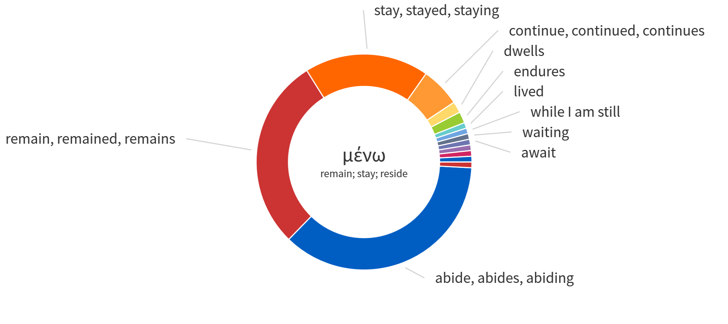

- Look again at the attached slide from the message this morning about the meaning of Abide. To Abide means in part to Trust and Rest. What freedom does this give us as Christians both personally and in the world around us.
- How does the church follow or misunderstand these words of Jesus? Give examples of bearing fruit by trusting in the vine vs. bearing “fruit” of our own accord.
- Read some of the following passages which provide instruction on how to Abide. Discuss how the church has and should practice these.
  - John 15:4,
  - Hebrews 12,
  - Galatians 5:4, 22-25,
  - Proverbs 4:26-27,
  - Matthew 22:40,
  - Romans 5:9-10, 8:38-39
Took - Personal Application
- This application focuses on how God is calling us to respond. This could be personally, as a family, small group, or church. It could be something to believe, to meditate on, to say or do this week.
- Over the centuries, abiding has been reinforced by the spiritual disciplines. They are not a recipe for success, nor should they be seen as legalism, but they can be pathways for us to abide in Him. Brainstorm some disciplines that you could practice even in the coming week, disciplines that you can start or revive in your life to help you abide.
- How does the knowledge of “abiding in Him” meaning “Trust and Rest” change the way we see our day to day strivings? How should it? How have you tried to abide on your own?

Time of Prayer

